Resources

Compiled by Teachers of Trinity Preschool for students and families

Virtual Field Trips:

San Diego Zoo |  | The San Diego Zoo has a website just for kids with amazing videos, activities, and games. Enjoy the tour!
Yellowstone National Park Virtual Field Trip |  | Mud Volcano, Mammoth Hot Springs, and so much more.  Tour Yellowstone National Park!
MARS!!! | 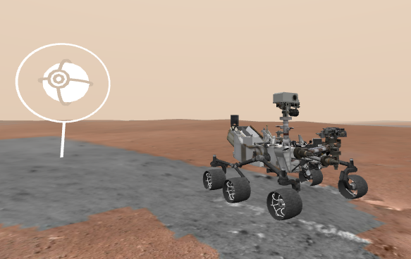 | Explore the surface of Mars on the Curiosity Rover.  They are updating from WEBVR to WEBXR now, but 360 Mode offers a digital view!
Animal Cameras |  | Live Cams at the San Diego Zoo  Monterey Bay Aquarium live cams  Panda Cam at Zoo Atlanta  6 Animal Cams at Houston Zoo  Georgia Aquarium has Jellyfish, Beluga Whales, and more
Virtual Farm  Tour |  | This Canadian site FarmFood 360 offers  11 Virtual Tours of farms from minks, pigs, and cows, to apples and eggs.
U.S. Space and Rocket Museum in Huntsville, AL |  | See the Saturn 5 Rocket on YouTube and more on this tour thanks to a real father/son outing.
Discovery Education Virtual Field Trips |  | A few of the field trip topics include  Polar Bears and the Tundra  Social Emotional Skills  STEM  manufacturing
The Louvre |  | Travel to Paris, France to see amazing works of art at The Louvre with this virtual field trip.
The Great Wall of China |  | This Virtual Tour of the Great Wall of China is beautiful and makes history come to life.
Boston Children’s Museum |  | Walk through the Boston Children’s Museum thanks to Google Maps!  This virtual tour allows kids to explore 3 floors of fun.

Links to educational websites:
http://thekidzpage.com/
www.pbs.com
www.starfall.com
www.funbrain.com
www.coolmath.com
www.storylineonline.com
www.abcya.com

Ideas to keep your child busy during the pandemic:
Talk to your child at the grocery store. Have them count items, look for colors and letters.
Make an obstacle course at home Tell child to go under the table, up the stairs, over the stool etc. (learning directional words)
Read stories, tell stories, draw stories.
Go for a walk and look for signs of spring.
Have a scavenger hunt at home. Find red things, find round things etc
Create pictures with pasta and glue or make a collage with magazine pictures.
Talk about the weather and make a chart to record each day.

Additional resources:
https://www.internetessentials.com/
(Comcast is offering free internet during this time)

http://www.hbgsd.k12.pa.us/
(Find information about food pickup at various Harrisburg locations)
*We are currently setting up a virtual classroom so that our students can get some level of continued instruction from staff at home. More information will follow regarding how to log in, times, and topics offered.

Contact info for Trinity Preschool Teachers:
Jennifer Morris 717-857-5307
Deb Donnelly 717-461-0051
Rachael Dudu 717-712-4217
Kellan Morris 717-460-4631

